**University of Petroleum and Energy Studies**

School of Computer Science

Department of Cybernetics



**Graphics & Animation Tools**

**LAB FILE**

**(Session: 2020-2021)**

Course: B. Tech with Specialization in Open Source and Open Standards





**Experiment 2 - Design of Logo using GIMP.**

**Step 1 :**

Draw the LOGO/Picture which you want to use and save it in your computer.

**Step 2 :**

Open GIMP.

**Step 3 :**

Select File → new file and choose a size screen with white background.

**Step 4 :**

Now, again open File → Open as Layers → Select the image you want to use.

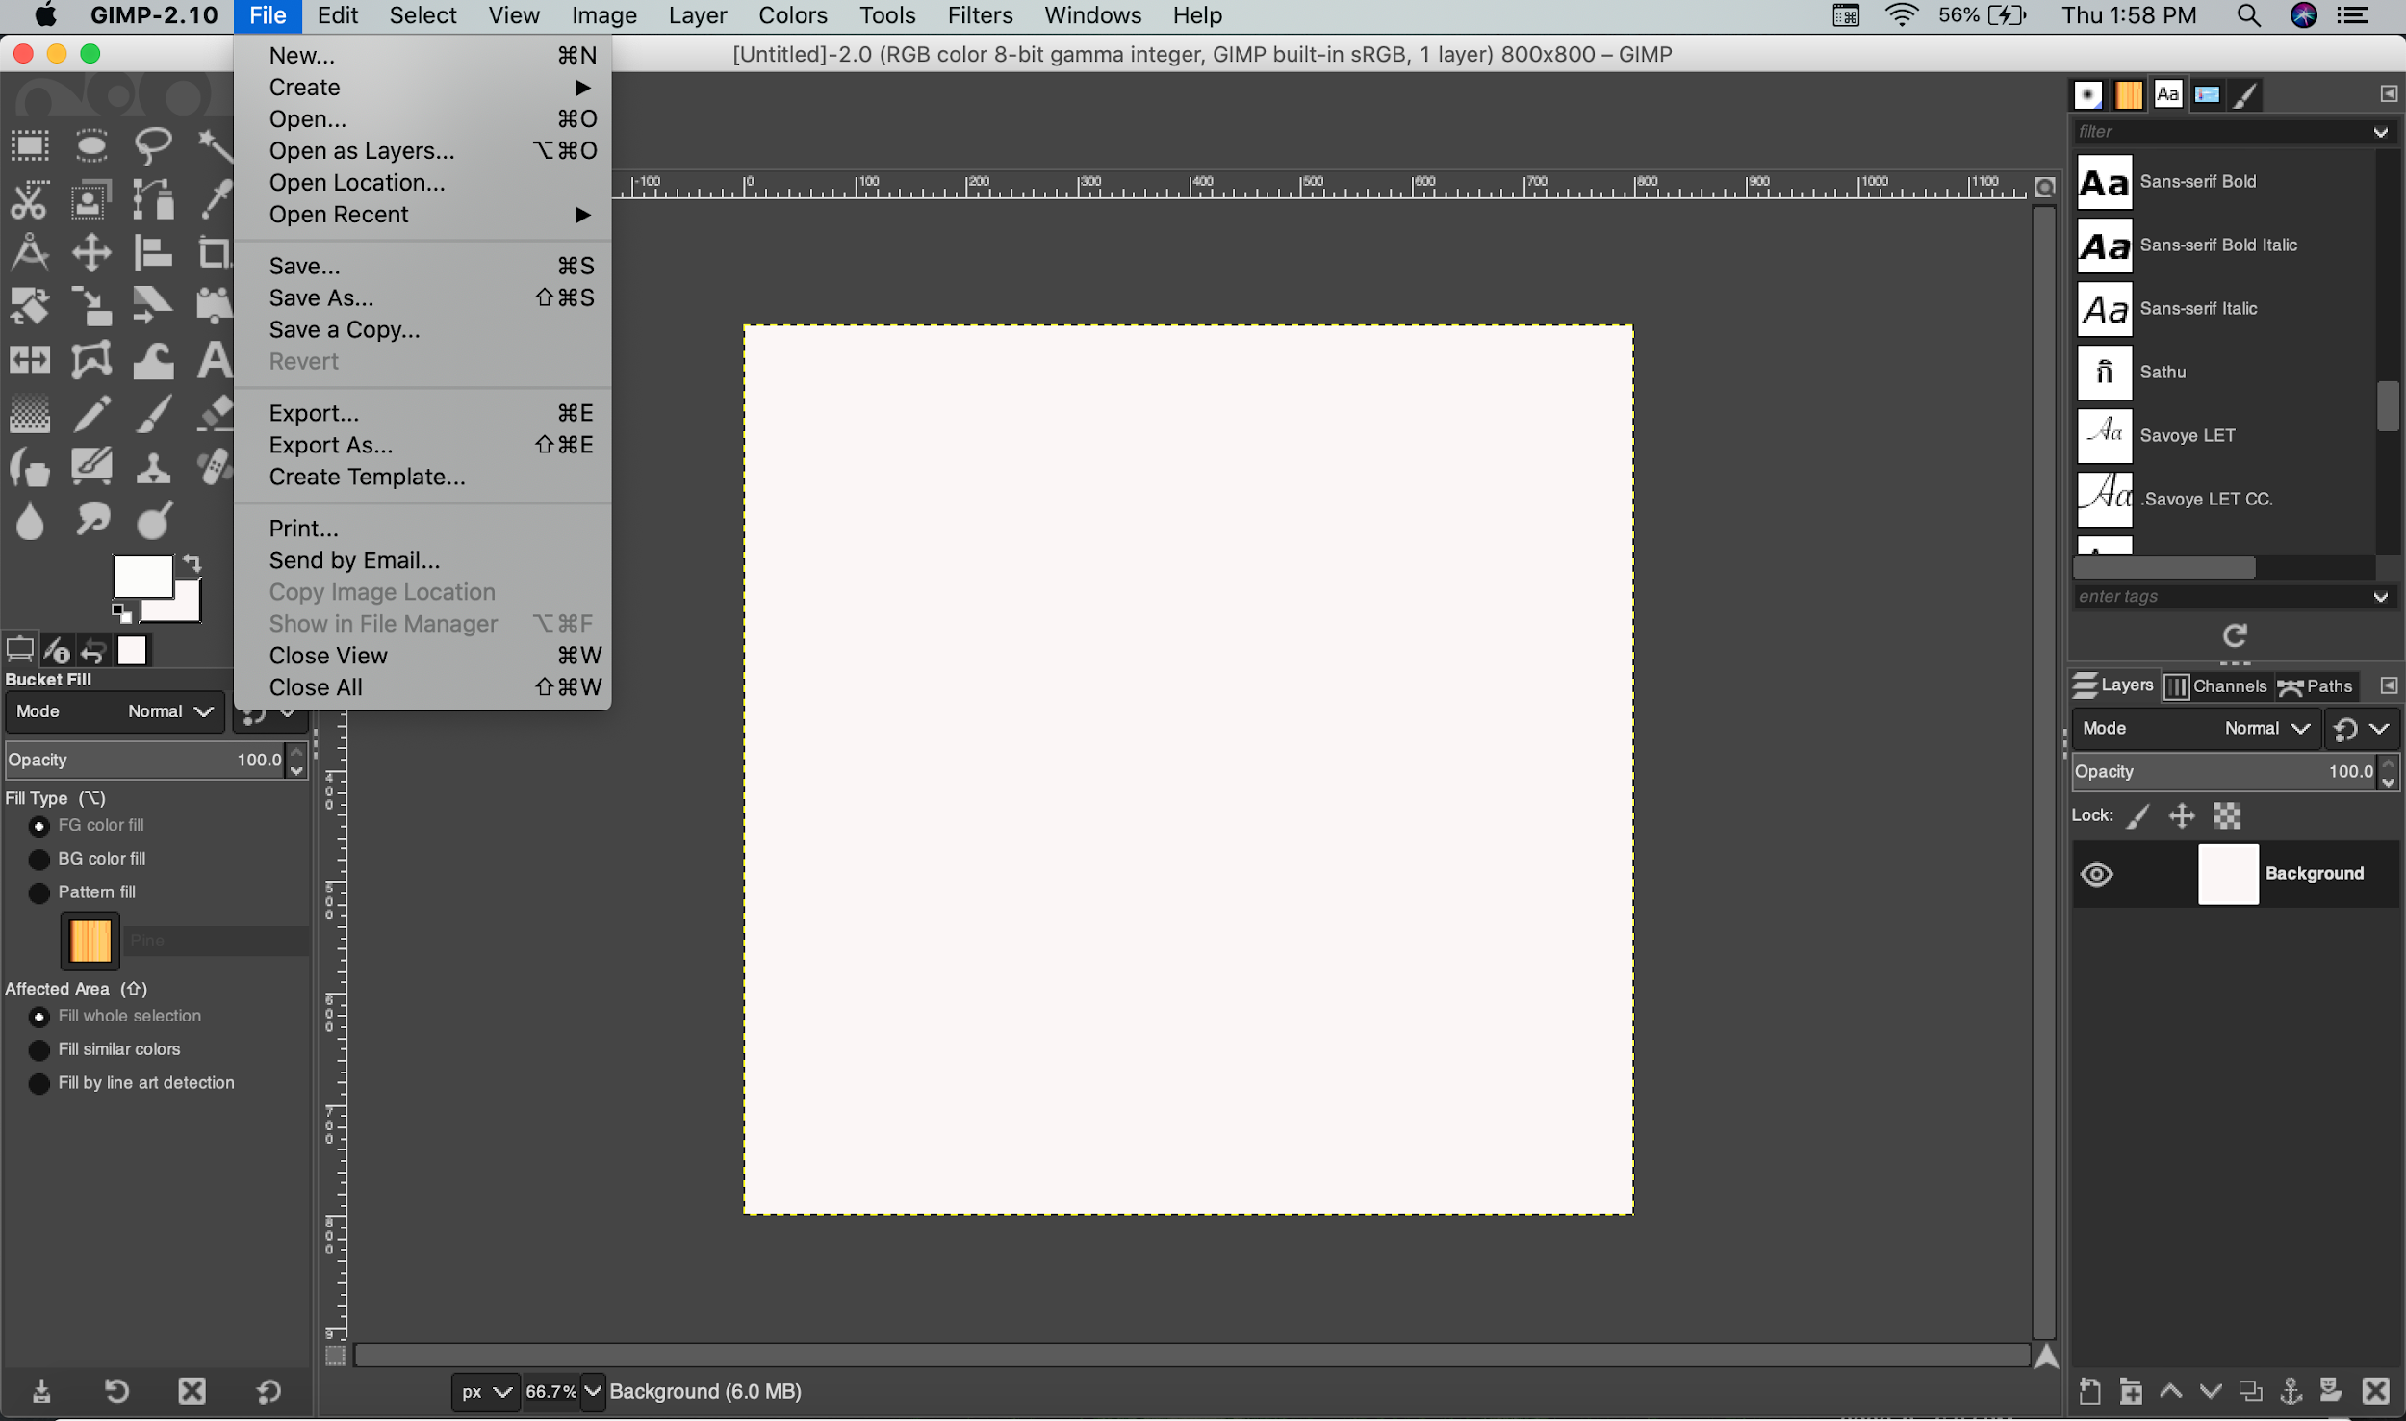

**Step 5 :**

After the image appears, select Free select tool and start selecting the regions which you want to keep by making borders around that picture.

**Step 6 :**

After selecting the region, right click Select From path.

**Step 7 :**

Now create a new layer by clicking the small icon at bottom right and, name the layer accordingly.

**Step 8 :**

Similarly repeat this process until all the regions required are there in the form of layer.

**Step 9 :**

Now, to make the image look more interesting, fill the colour by selecting the colour of your choice. Use the bucket fill tool for this.

**Step 10 :**

To add text, select the Text tool from the toolbar, write the text and choose the font colour of your choice.

**Step 12 :**

Once everything is done save the file by going to File Export As Export.

-------------------------------------------------------------------------------------------------------------------